Sunday  July 2017 Halifax Bridge World 902-454-4098 | Monday | Tuesday | Wednesday | Thursday | Friday | Saturday  OPEN 12:30  Strat Pairs!
 |  |  |  |  |  | 1
2 | 3 NAP Strat Open  Pairs A/B/C 9:15  No afternoon game. Join in the morning game!  No evening game the summer | 4 NAP Bargain Tues. Strat Open Prs A/B/C 12:30  0-300 Strat Pairs A/B/C 6:30 | 5  GNT Team Game  12:30 pm  NAP Strat Open  Pairs A/B/C 7pm | 6 Supervised Play  9:30 – 11:30  0-1500 Strat  Open Pairs 12:30  Where’s Waldo  Open Pairs 7pm | 7  NAP Strat  Open Pairs  A/B/C 9:15 | 8  NAP  Strat Open Pairs A/B/C 12:30
9 | 10 NAP Strat Open Pairs A/B/C 9:15  Gentle Duplicate  A/B/C 12:45  No evening game for the summer | 11 ACBL International Fund/Brunch Game  11:00 Start  0-300 Strat Pairs A/B/C 6:30  0-300 Strat Pairs A/B/C 6:30 | 12  GNT Team Game  12:30 pm  NAP Strat Open  Pairs A/B/C 7pm | 13 Supervised Play  9:30 – 11:30  0-1500 Strat  Open Pairs 12:30  Where’s Waldo  Open Pairs 7pm | 14  NAP Strat  Open Pairs  A/B/C 9:15 | 15  Happy Birthday!  NAP Strat Open Prs  A/B/C 12:30
16  JULY 30th  Summer Festival Team Game  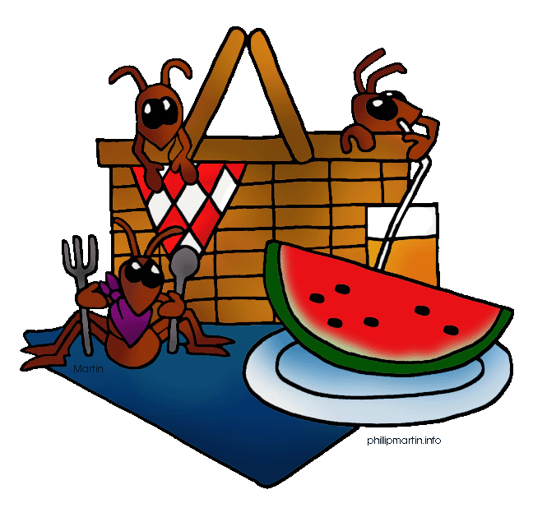  2 Sections!  0-500 C.C.C.  AND  OPEN GNT  Teams  12 noon for Picnic  12:30 Bridge | 17 NAP Strat Open Pairs A/B/C 9:15  Gentle Duplicate  A/B/C 12:45  No evening game for the summer | 18 NAP Bargain Tues. Strat Open Prs A/B/C 12:30  0-300 Strat Pairs A/B/C 6:30 | 19  At the Beach! Team Game resumes in September!  NAP Strat Open  Pairs A/B/C 7pm | 20 Supervised Play  9:30 – 11:30  0-1500 Strat  Open Pairs 12:30  Where’s Waldo  Open Pairs 7pm | 21  NAP Strat  Open Pairs  A/B/C 9:15 | 22  NAP  Strat Open Pairs  A/B/C 12:30
 | 24 NAP Strat Open Pairs A/B/C 9:15  Gentle Duplicate  A/B/C 12:45  No evening game for the summer | 25 NAP Bargain Tues. Strat Open Prs A/B/C 12:30  0-300 Strat Pairs A/B/C 6:30 | 26  At the Beach! Team Game resumes in September!  NAP Strat Open  Pairs A/B/C 7pm | 27 Supervised Play  9:30 – 11:30  0-1500 Strat  Open Pairs 12:30  Where’s Waldo  Open Pairs 7pm | 28  NAP Strat  Open Pairs  A/B/C 9:15 | 29  NAP  Strat Open Pairs  A/B/C 12:30
 | 31 NAP Strat Open Pairs A/B/C 9:15  Gentle Duplicate  A/B/C 12:45  No evening game for the summer | HBW is on Summer Schedule in July. To help celebrate CANADA`s 150 Birthday, we have lots of opportunities to win RED points. Join us on July 11th for Brunch and Bridge – an earlier start but that`s because of food!  July 30th- Fun for all. Sign up at the club to reserve your spot

